15.01.2010
CME 2003 LOGIC DESIGN
FINAL EXAM

(20) | 1. | The following boolean function (with its don't cares) is given:  F (A,B,C,D) = Σm (1, 3, 7, 12, 13)  d (A,B,C,D) = Σm (0, 5, 8, 11)  - Find both minimum sum of products and minimum product of sums expressions using Karnaugh map simplification method.  - Draw the combinational circuit for the simplest function using only NAND gates.  - This function can be implemented by using 4-to-1 multiplexer? Show the circuit if it is possible.  - Is it possible to implement the function above if we have only 2 X 4 decoder ?  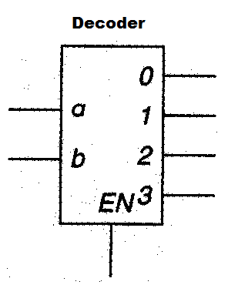
(20) | 2. | - Using JK flip flops design a counter to produce following sequence: 4 5 3 0 1. (Give only the expressions for the J and K inputs. No need to draw the circuit.)  - Determine the behavior of the circuit in the case of entering unused states.
(20) | 3. | - Design a circuit for converting following analog signal to 3-bit binary digital signal.  - If the analog input signal in following figure is sampled every 40μ second, determine the binary output codes.  - To increase the quantization quality, give the solution and its cost.  - To reach optimum conversion, sampling frequency what will be?  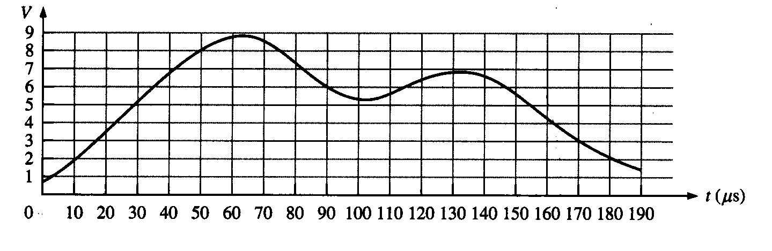
(10) | 4. | The decimal numbers -47 and 137 are to be stored in a 8-bit two’s complement format. Show how they are stored.
(10) | 5. | What are the differences between an asynchronous counter and a synchronous counter? Which of them is better? Why?
(30) | 6. | - Analyze the clocked synchronous state machine below and then draw a state diagram for this state machine (x: input, z:output).  - Is this machine a Mealy machine or a Moore machine? Explain?  - Fill in the transition/output table for the above state machine.  - Draw the Flow Chart for this ASM.  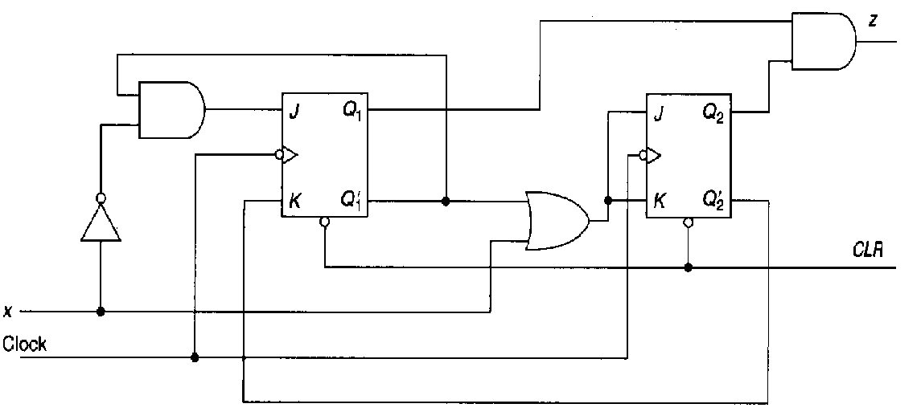
  Present States | Next States |  | Output
  Present States | X = 0 | X = 1 | X = 0 | X = 1
  Q₂ Q₁ | Q₂⁺ Q₁⁺ | Q₂⁺ Q₁⁺ | Z | Z
  0 0
  0 1
  1 0
  1 1

